PAPER TITLE (10 PT BOLD WITH CAPITAL LETTERS)

¹LAST NAME First name, academic degree, ²LAST NAME first name, academic degree (10 pt bold)
¹Institute (10 pt)
E-mail: (10 pt)
²Institute
E-mail:

Keywords: List 3-5 keywords (10 pt).

If your paper is accepted to the ISCAME 2019 conference, then the extended abstract is the version that will be published in the conference Book of Abstracts electronic format. This means that the extended abstract needs to contain all the information that the author feels is essential that a reader of the full paper is made aware of. Please take into consideration that the main sentences of the abstract must present the following aspects: placing the work in context (briefly review of the pertinent literature); the purpose of the work (present the scope and objectives of the paper and state the problem); explaining what was done (the methodology must be clearly stated and described in sufficient detail; the author shall explain the research question, describe the research framework and the method applied in detail and why the chosen method are suited for the problem; it should be highlighted why the research question is relevant to theory and practice); indicating in detail the main results/findings of the work should be an essential part of the extended abstract; the most important conclusions of the paper (principles and generalisations inferred from the results, theoretical and/or practical implications of the work, recommendations).

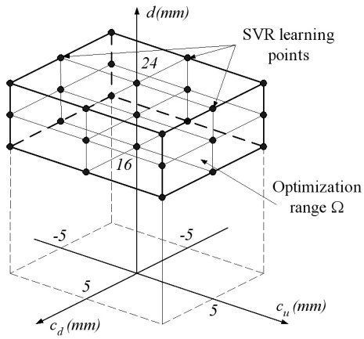
Figure 1 Optimization range and learning points

The extended abstract shall be written in 10-point Times New Roman, text should be justified and single line spacing. No lines between paragraphs. Extended abstracts can contain figures/images and tables and they should be centered. Page format should be 210 mm width and 297 mm height, with margins 20 mm wide from the right, left and bottom, and 30 mm wide from the top. Pages will be numbered, currently 1 and 2. The extended abstract should be written clearly and in good English and must be written on two pages.

Table 1 Data for the investigated rubber part
Geometry |  | Numerical material properties
Height $(H)$ | 120mm | Material constant $(μ_{10})$ | 0.8MPa
Outer diameter $(D)$ | 120mm | Material constant $(μ_{01})$ | 0.2MPa
Hole diameter $(d)$ | 20mm | Bulk modulus $(κ)$ | 1000MPa

Some equations from the paper could also be placed in extended abstract. They should be centered, but with no any number in parentheses.

$$ΔW\left(d^{opt}\right)=\min_{d∈Ω}{ΔW(d)}.$$

The extended abstract must be sent, as DOC or DOCX file, to the conference organizer by E-mail: iscame@eng.unideb.hu until Monday 28th of October 2019.

Acknowledgments

The described work was carried out as part of a project supported by the National Research, Development and Innovation Office – NKFIH, K123456.

References

- Drebin, F., Black, C. (2014), Optimization of the Shape of Axi-symmetric Rubber Bumpers. Strojniski vestnik-Journal of Mechanical Engineering, 60(1), 61-71.
- Hood, R., Little, J. (2013), Shape Design of Rubber Part Using FEM. International Review of Applied Sciences and Engineering, 4(2), 85-94.
- Lee, J.S. and Kim, S.C. (2007), Optimal Design of Engine Mount Rubber Considering Stiffness and Fatigue Strength. Journal of Automobile Engineering, 221(7), 823-835.
- Bonet, J. and Wood, R.D. (1997), Nonlinear Continuum Mechanics for Finite Element Analysis. Cambridge University Press, UK.

