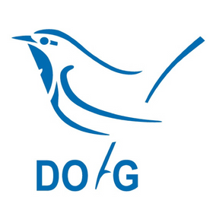
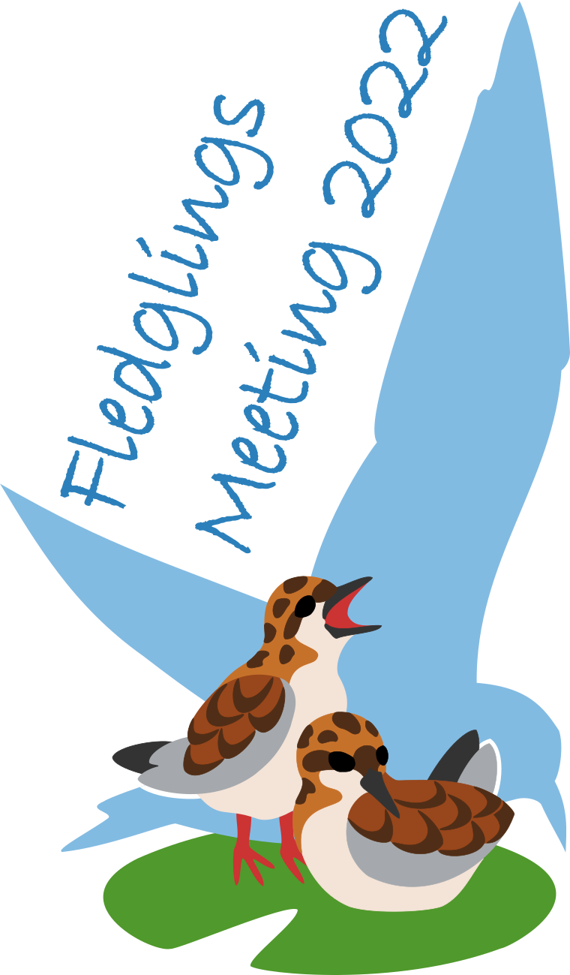

Application for DO-G Travel Stipend
for the 3rd EOU Fledglings Meeting

The German Ornithological Society supports conference attendance for 10 early career researcher from environments that cannot cover participation in the Fledglings Meeting (especially from low and medium income countries). We will also consider applications due to other forms of hardship on a case-by-case basis. We will also consider the travel distance between the conference venue and the sending institution.

Please only apply if you have no alternative funding sources, after exploring all options.
Support can be given for costs of maximally € 250, pending on a justified budget request.
Please fill in the application form below to inform our decision-making.
Award decisions will be made by a small international selection committee of EOU council members.

The closing deadline for applications is 20 June 2022, decisions will be communicated in early July. Submit the form to EOU conference stipend committee (eoufledglingmeeting@gmail.com).

Personal information
First name
Last name
Institution / company
Country of residence
E-mail

Role in Fledglings Meeting Debrecen?
Indicate all that apply
1st time EOU
Poster presentation (give title)
Oral presentation (give title)
Neither, but ... (briefly indicate your motivation for attending the Fledglings Meeting conference)

Professional status?
Indicate which applicable
Student (indicate university)
Early career-researcher with completed PhD (indicate PhD year)
Optional: other (e.g., NGO, company, unemployed etc.)

If you are not an early-career researcher from low and medium income countries, are there other forms of hardship that you would like to briefly tell us about?

Indicative budget request?
Please note that, DO-G can offer maximum € 250/person.
Indicate expected need
Registration
Travel
Accommodation

