Use of Mathematical Software in Practical Fracture Mechanics (use the style “Title”)
I. Kocsis, B. Author, C. Author (use the style “Authors”)
University of Debrecen, Faculty of Engineering, Department of Basic Technical Studies, kocsisi@eng.unideb.hu
University of …
University of … (use the style “email”)
Abstract. Abstract has to be written in English. Paper can be written in English. (use the style “Abstract”)
Introduction (use the style “Heading1”)
dcb klhc ekcbh ecuibe lcieb cleihcb eflcihefb clib cilhb efchieb oeihcb ioch oibhc ohicb ocihb hibc oichb coethib ctoicho ibhc hitb ocihb cohico cihb cobhic etoichbet ociethbc oetihcb eoichbe olciehb coeihcb
dcb klhc ekcbh ecuibe lcieb cleihcb eflcihefb clib cilhb efchieb oeihcb ioch oibhc ohicb ocihb hibc oichb coethib ctoicho ibhc hitb ocihb cohico cihb cobhic etoichbet ociethbc oetihcb eoichbe olciehb coeihcb (Text)
1. Abcd efgh ijklm (use the style “Heading1”)
1.1. Abcd efgh ijklm (use the style “Heading2”)
1.1.1. Abcd efgh ijklm (use the style Heading3)
dcb klhc ekcbh ecuibe lcieb cleihcb eflcihefb clib cilhb efchieb oeihcb ioch oibhc ohicb ocihb hibc oichb coethib ctoicho ibhc hitb ocihb cohico cihb cobhic etoichbet ociethbc
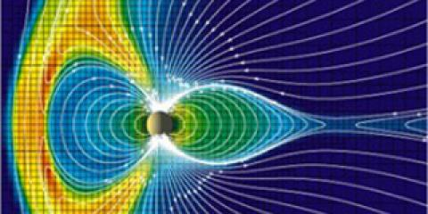
Figure 1. This is a picture.
Table 1. This is a table.
wg iwex wetuxv weiutxf wixtuwexuwetxv weiteg tev etdtv etfvt tv tuvwe vcjwtcv wectuv wecwetvcv oetihcb eoichbe olciehb coeihcb (use the style “Text”)
- ehb cviehb eh
- ibjh lidcb li
equation editor of MS Word 2007 is to be used
equations are centred
$$f\left(x\right)=\frac{e^{-x^{2}}}{\sin{\frac{x}{2}}}$$
$$x+y=u+v (1)$$
References (use the style “Heading1”)
[1] A. Author, Title of the book or paper, Publisher, 34-56.
[2] A . Author, Title of the book or paper, Publisher, 34-56. (use the style “Reference”)

